**MAKERERE UNIVERSITY**

**SCHOOL OF COMPUTING AND INFORMATICS TECHNOLOGY**

**COLLEGE OF COMPUTING AND INFORMATION TECHNOLOGY**

**GROUP 30**

|  |  |  |
| --- | --- | --- |
| **STUDENT NAME** | **REGISTRATION NUMBER** | **MODULE** |
| **GAGAMBWA BRIAN** | 19/U/8650/EVE | **System configuration, and Dashboard Authentication** |
| **NNABAKKA MARIA GONZAGA** | 19/U/8468/EVE | **HR Management** |
| **KAWALA FRIDAH JOSEPHINE** | 19/U/8167/EVE | **Product and Sales management** |
| **ZZIWA MICHAEL** | 19/U/8631/EVE | **Customer Base Tracking and Advisory Module** |
| **SSEKYONDWA JONATHAN** | 19/U/12336/PS | **Reporting** |

**MANUAL FOR SYSTEM (MUKWANO INDUSTRIES)**

* **The Manager starts by signing into the system.**

He/she does not have to register because his/her details are put during migration of tables and this prevents others from registering as managers too.

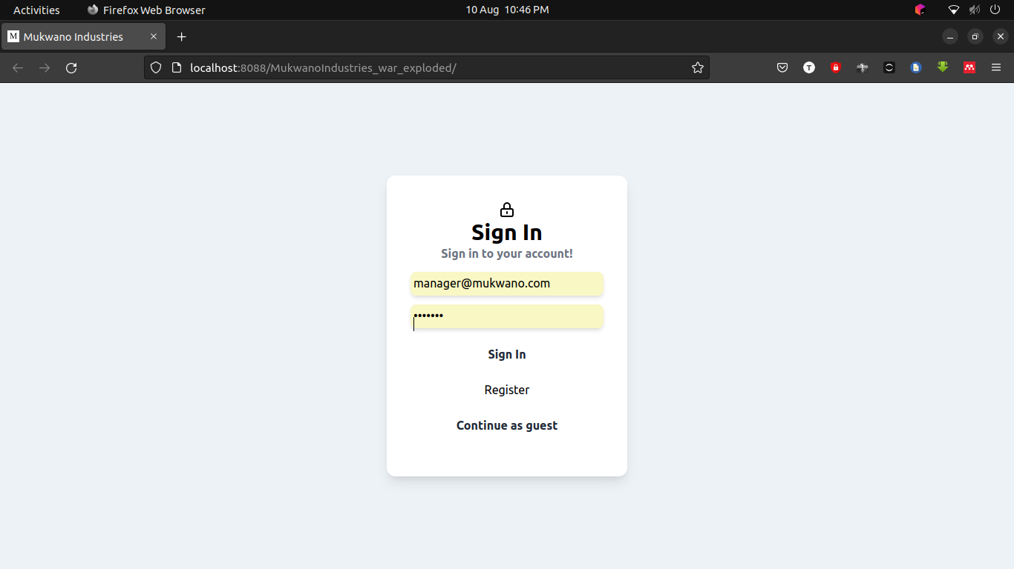

* **The Manager registers the products as seen below**

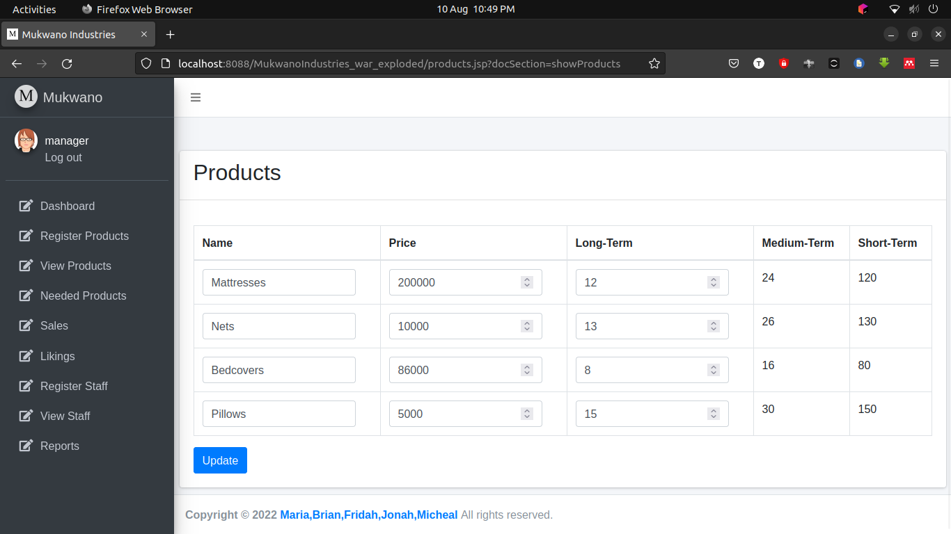

* **The products are viewed after being added into the system.**
* 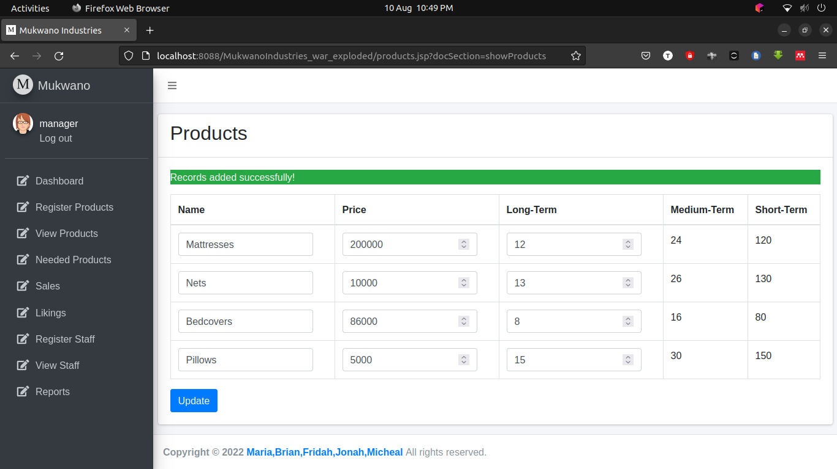
* **The manager registers new staff**

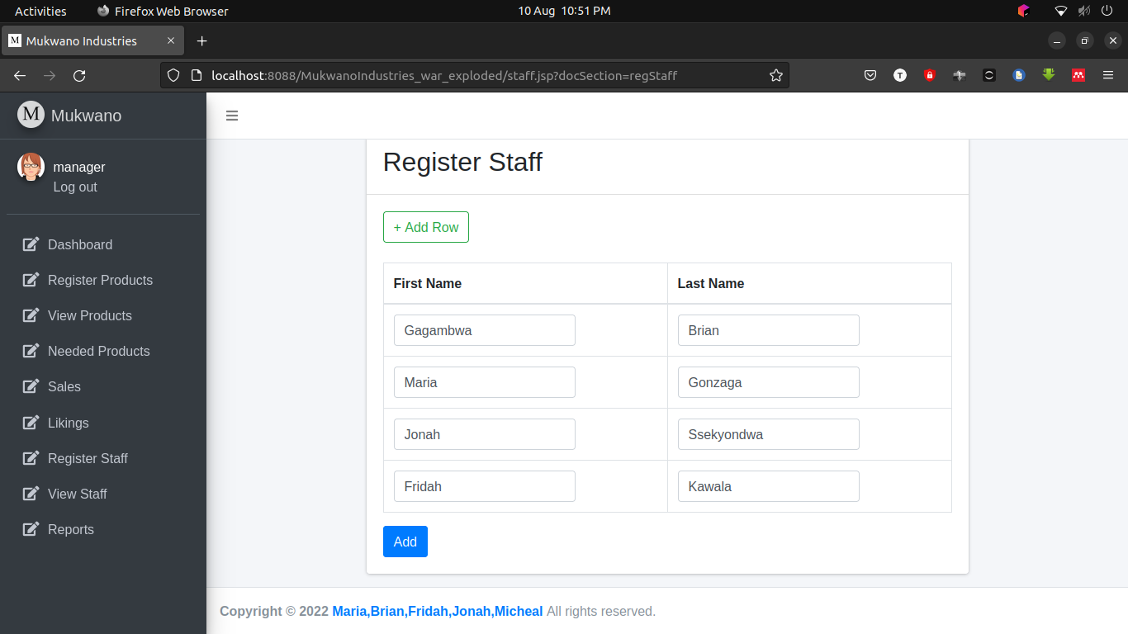

* **Each staff member is registered with a product**

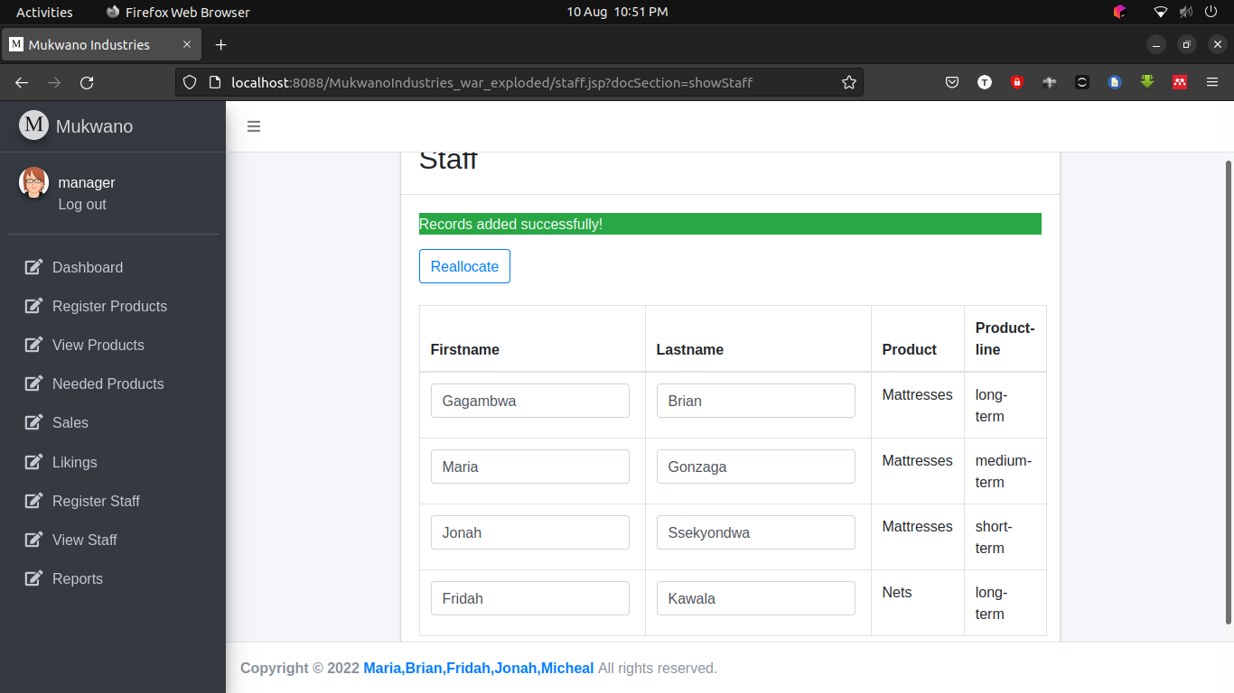

* **The manager makes reports**

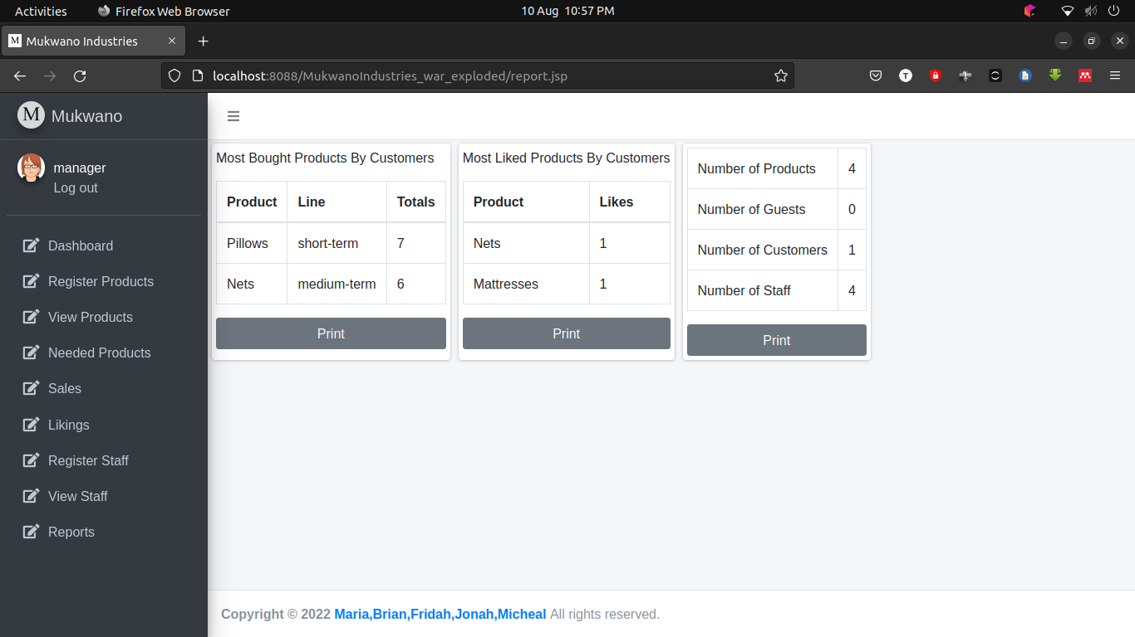

* **The manager prints the reports**

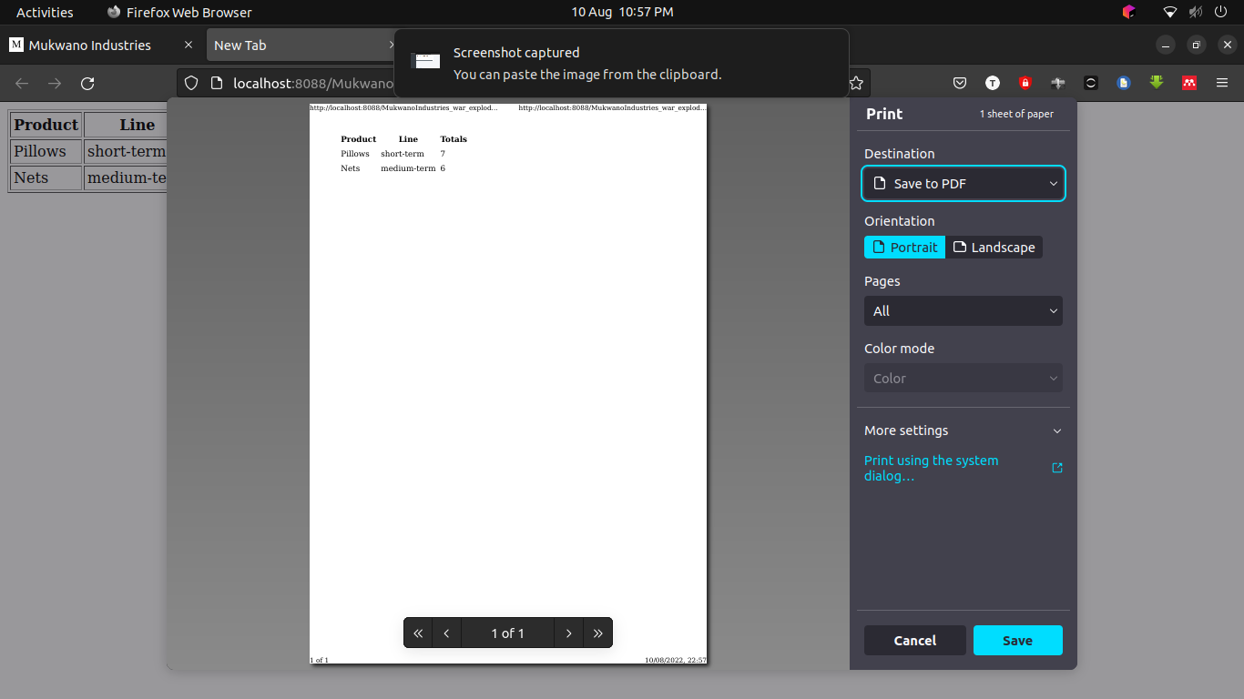

* **The views the products liked by customers, products bought by customers, the number of products, number of guests, number of customers and number of staff.**

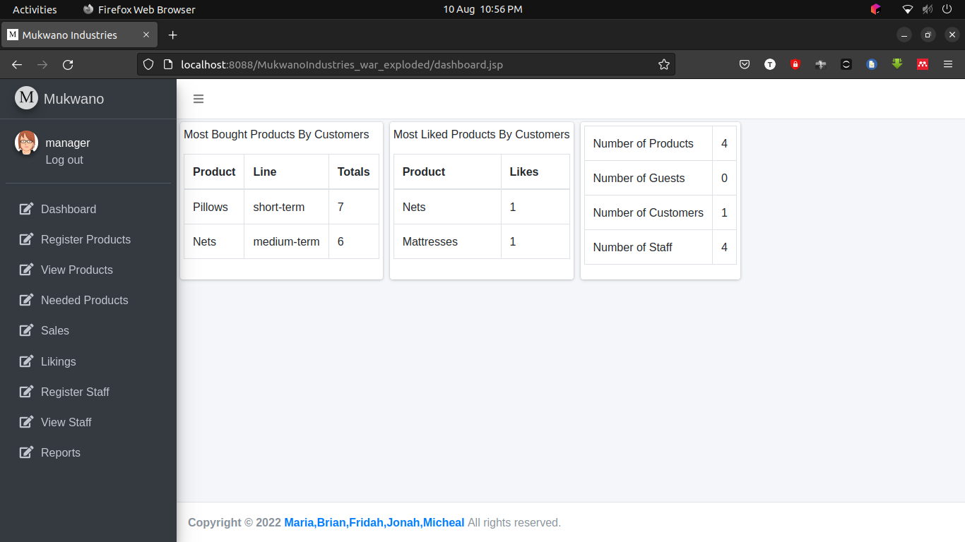

* **The manager views the sales made.**

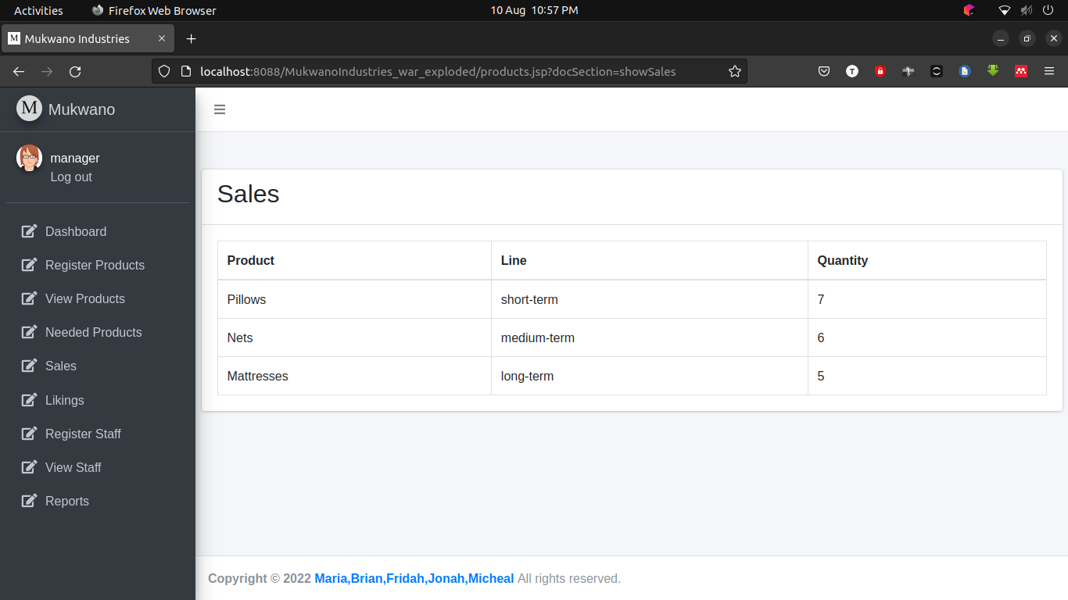

* **The customer registers into the system.**

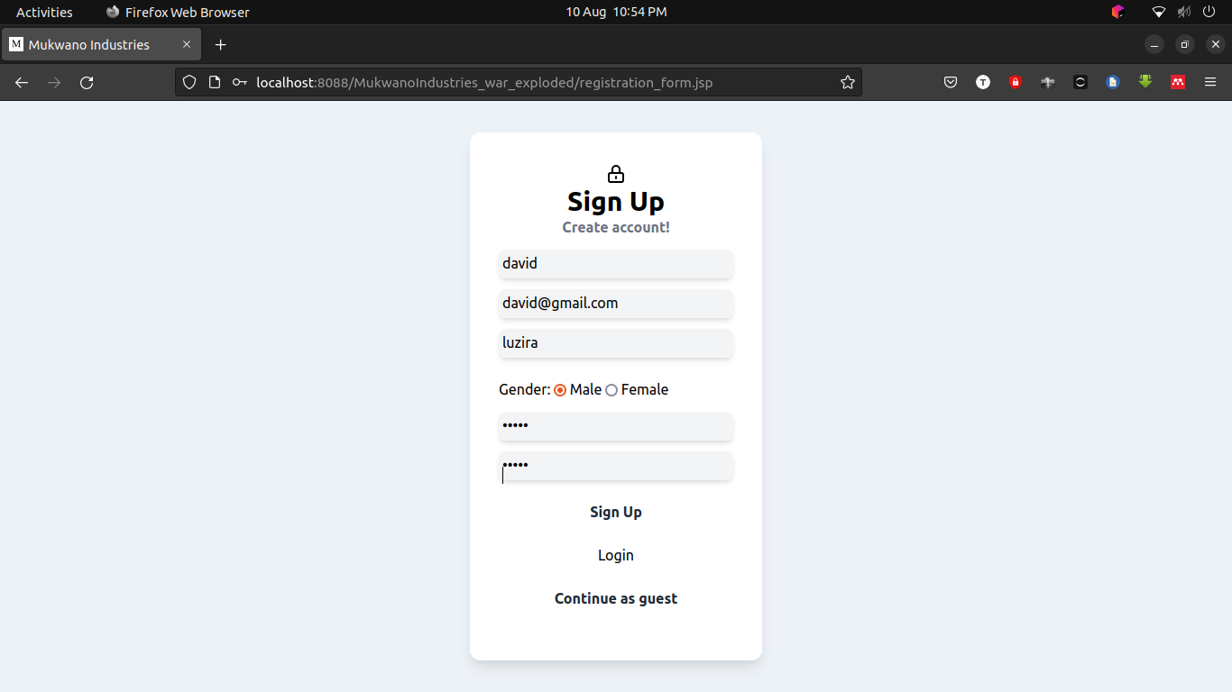

* **The customer adds products to the cart**

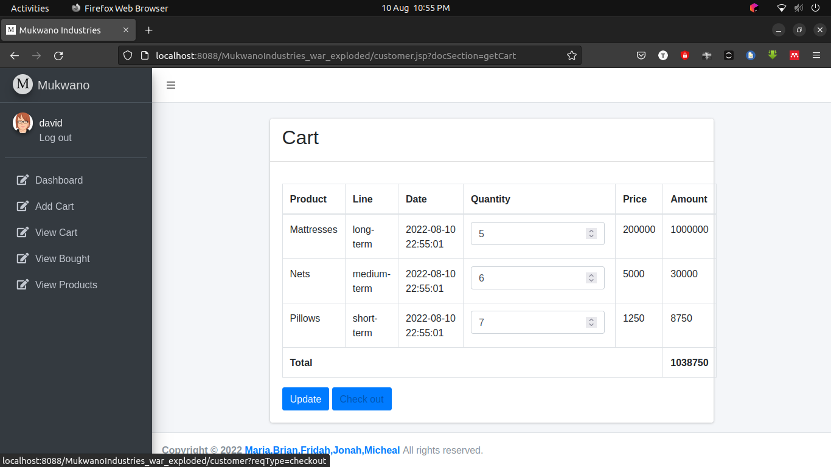

* **The products are added to cart**

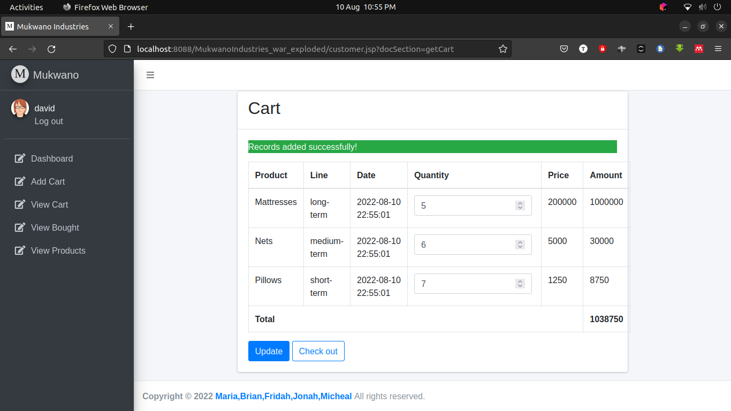

* **The customer views products bought**

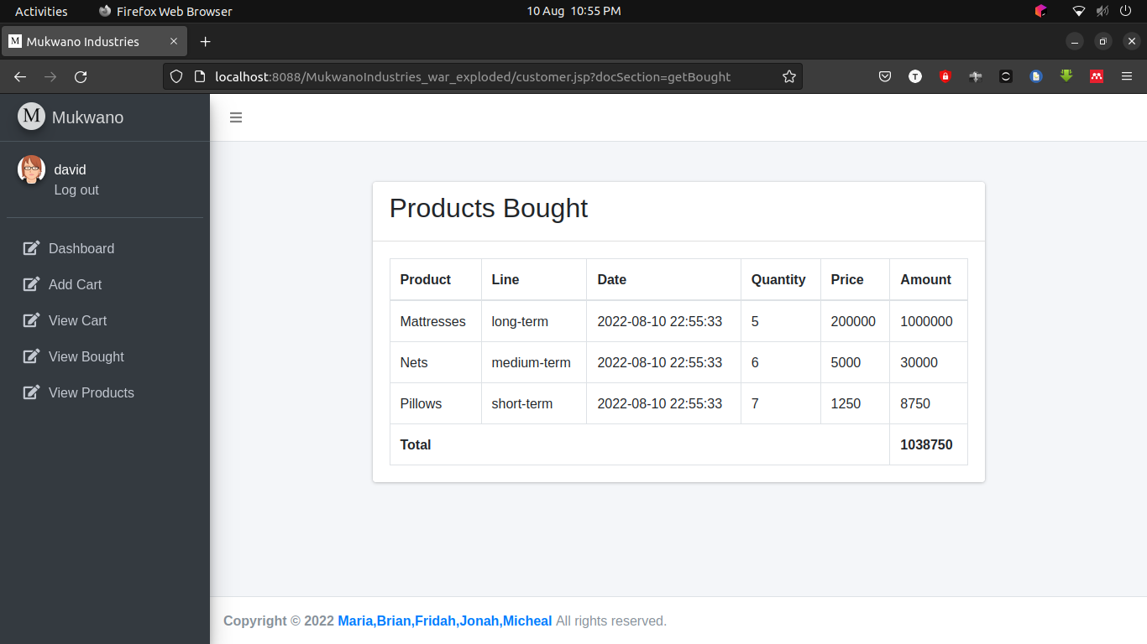

* **The customer views the products and can like or dislike them**

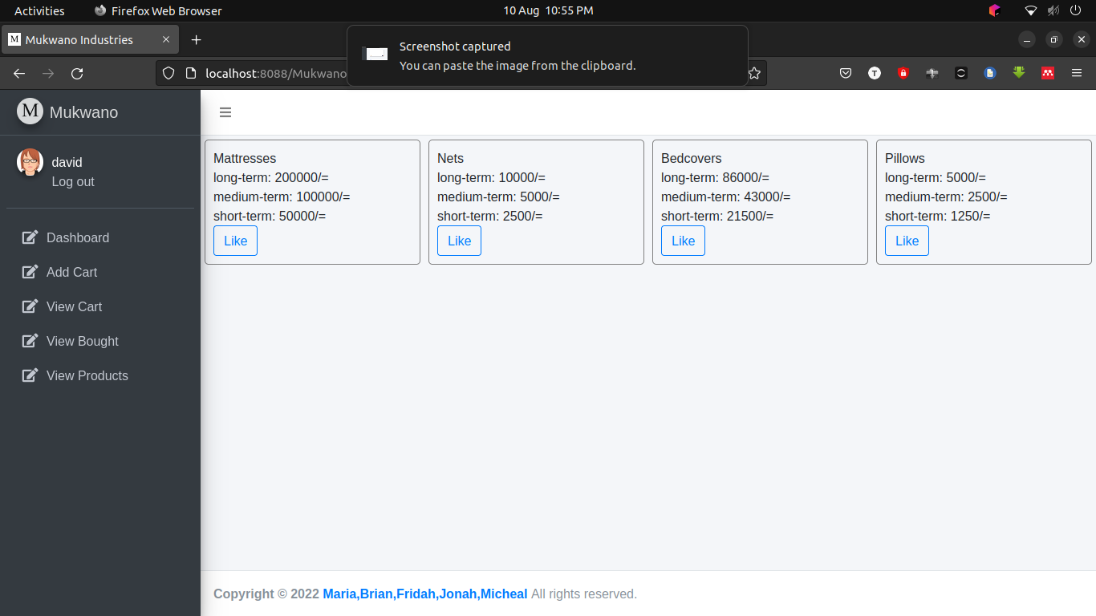

* **The customer views the liked products and those bought**

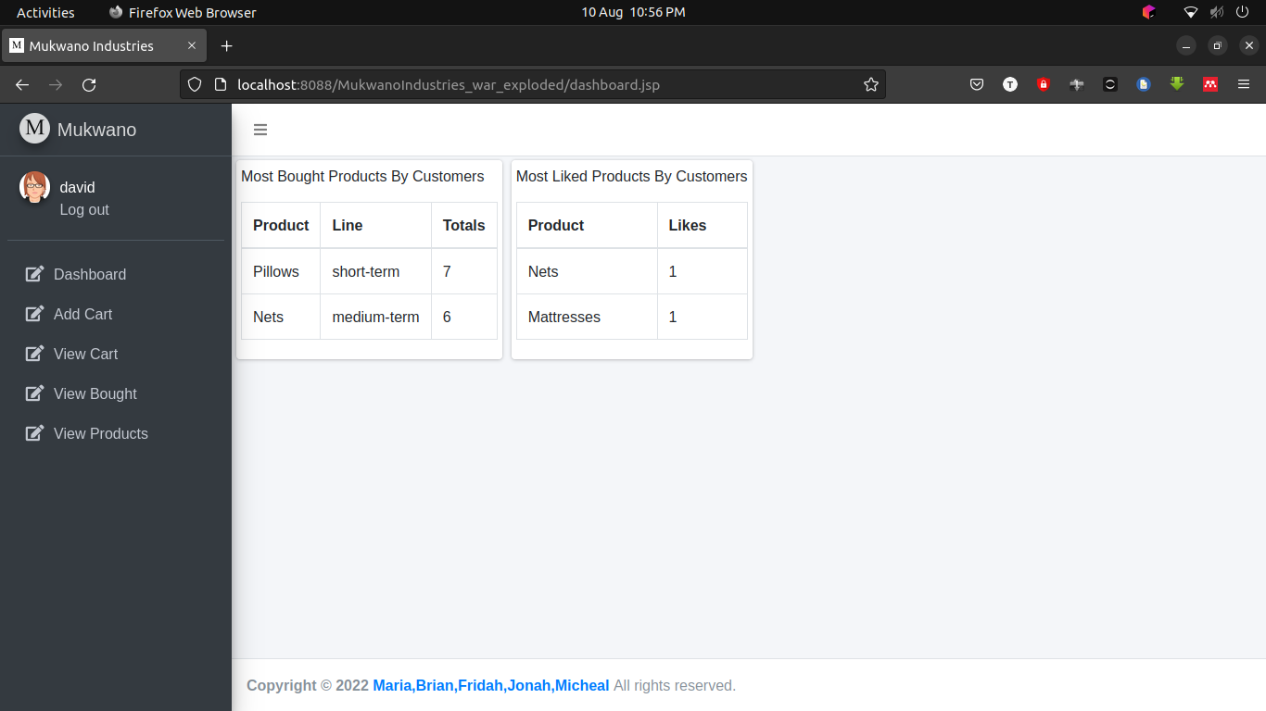

**GitHub Link:**

https://github.com/Brian-gagambwa/Mukwano-Industries.git